SQL Server Reporting Services
Lab Book

Copyright © 2011 IGATE Corporation (a part of Capegemini Group). All rights reserved.
No part of this publication shall be reproduced in any way, including but not limited to photocopy, photographic, magnetic, or other record, without the prior written permission of IGATE Corporation (a part of Capegemini Group).

IGATE Corporation (a part of Capegemini Group) considers information included in this document to be confidential and proprietary.
Document Revision History

Date | Revision No. | Author | Summary of Changes
25-Jan-2013 | 1 | Ajit Jog | Content Creation
26-Sep-2016 | 2 | Shital Patil | Gauge, Indicator, Databar, Sparkline, report builder 3.0 labs added

Table of Contents

Document Revision History 3
Table of Contents 4
Creating a Tabular Product Listing Report 5
Creating a drill down group report 9
Using Subreport 12
Creating a Gauge report 15
Creating a Indicator report 17
Creating Databar report 19
Creating Sparkline report 21
Creating a Report using Chart 22
Creating a Hierarchical Report 24
Creating and Customizing Report Model and using Report Builder 26
Creating DataBar Report using Report Builder 3.0 32
Creating Sparkline Report using Report Builder 3.0 35
Creating Chart Report using Report Builder 3.0 38

Lab 1 | Creating a Tabular Product Listing Report
Description | We will create a report which will show product details grouped according product category and add category wise subtotals/
Objective | To learn  - How to create Shared Data Source and Local Data Source  - Define Report DataSet  - Use Data Set and Table report item to create tabular report  - Define a row group  - Add Sub totals to group  - Add Expressions using Data Set fields

- Open BIDS IDE, Start New SSRS Project
  - File -> New Project , select Business Intelligence Project, Select Report Server Project template, Give Project Name IgateSSRSReportsDemo, clck ok
- Create Shared Data Source
  - In Solution Explorer , right click Shared Data Sources, click Add New Data Source
    - Type: MS SQL
    - For Connection String, click edit.. specify the credentials and other details.
- Right click Reports folder in Soln Explorer, click Add -> New Item.
  - Select report item template
  - Give ProductsReport as report name
- In Report Data Window,
  - Click New Data Source and create a local report level data source based on Shared Data Source of step 2
  - Click New Data Set
    - Create a dataset on local data source created in step 4.a
    - The Select Query for DataSet is:-

SELECT Products.ProductID, Products.ProductName, Products.UnitPrice, Products.UnitsInStock, Products.ReorderLevel, Categories.CategoryName,
Categories.CategoryID
FROM Products INNER JOIN
Categories ON Products.CategoryID = Categories.CategoryID
ORDER BY Categories.CategoryName, Products.ProductName

    - Click ok.
- From toolbox, drag a Table report item onto report designer surface.
- Right click the column header of 3rd column in table report item and insert a new column.
- Drag ProductId, ProductName, UnitPrice, UnitsInStock dataset fields onto the table columns. Set dark blue color, bold 10pt font size for column headers and for fields set fontsize 9pt

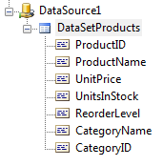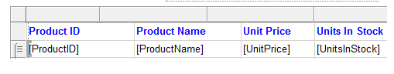

- Right click the column header of 4th column in table report item and insert a new 5th column.
- Type Stock Value in the 5th column header. Right click the textbox cell below the 5th column header, select expression and in the expression dialog box type following expression and click ok

=Fields!UnitsInStock.Value*Fields!UnitPrice.Value

- Right click the ProductId field textbox, select Add Group, under
Row Group – select Parent Group.
- In the Group dialog box
  - give group name as Category
  - select [CategoryName] from the drop down. Click ok
- Click Preview Tab the output should be as below:

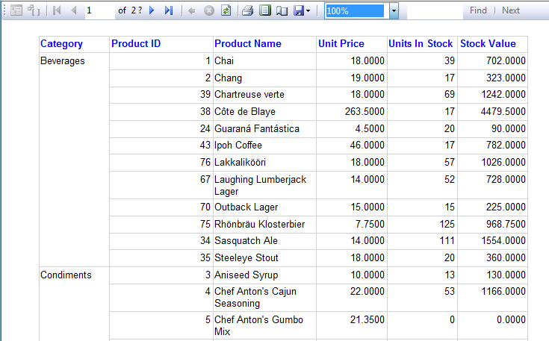

- Right Click CategoryName field textbox in the report table, Insert Row -> Inside Group- Below. Add such total 3 blank rows.
- In the middle row under stock value , right click the cell textbox and give following expression

=Sum(Fields!UnitsInStock.Value*Fields!UnitPrice.Value)

- Select the 2 adjacent cells and right click and merge and then type the following:

Total Stock Value for Category

- Drag a TextBox from toolbox on the top of table and give “Inventory Products Listing” as report heading and format it.
- Click Preview tab to see the result

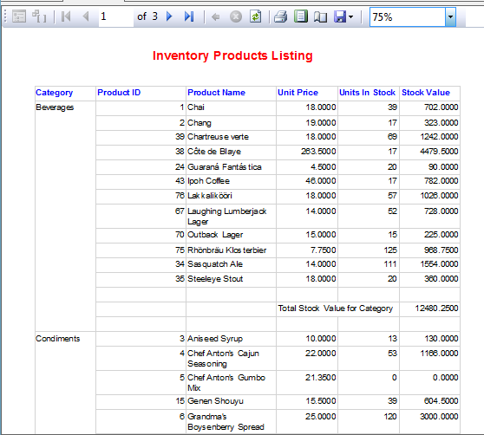

Lab 2 | Creating a drill down group report
Description | We will create a report which will show the orders placed by customers from various countries and it’s cities between specific dates
Objective | To learn  - How to create multiple nested groups.  - How to add drill down feature.  - Use Parameters for filtering.  - Dynamic Report heading through expression

- Add a new blank report
  - Right click Reports folder in Soln Explorer, click Add -> New Item.
    - Select report item template
    - Give DrillDownReportDemo as report name
- Create a local data source based on shared data source and define a data set using following select statement:

SELECT Customers.CustomerID, Customers.CompanyName, Customers.Country, Customers.City, Orders.OrderID, Orders.OrderDate, Orders.Freight
FROM Customers INNER JOIN
Orders ON Customers.CustomerID = Orders.CustomerID
ORDER BY Customers.Country, Customers.City, Customers.CompanyName

- Drag a table report item.
- Drag Orderid, OrderDate and Freight fields on to table columns.
- Right click OrderId field , Add Group , Parent Group under Row Group
  - Select companyname field in drop down
- Similarly Right click CompanyName field and a parent row group using field City.
- Again Right click City field and a parent row group using field Country
- Now in Row Groups pane below double click every group and rename the groups as grpcompanyname, grpcity and grpcountry
- Similarly change the column header for those group fields in the table.
- Add Subtotal to OrderId at company level.
  - Right click orderid field, Select Add Total
  - Aggregation will be added for orderid and freight.
  - Right click and edit the aggregate expresion for OrderId and change it to:

="Total Orders " + cstr(Count(Fields!OrderID.Value))
- Similarly right click companyname and city add subtotals for it. and change sum(orderid) expression to Count(Orderid)
- Format the table as below:-

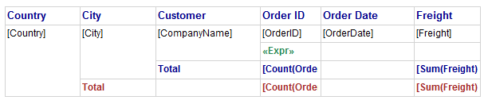
- Select the City and Country Field textboxes and note the textbox names.
- Double click grpcompanyname group in row groups pane, goto visibility tab, select hide, check Display can be toggled checkbox and select City Field textbox name from the drop down. Click.
- Similarly for grpcity group set the Country Field Textbox name for toggle.

- Preview the report.

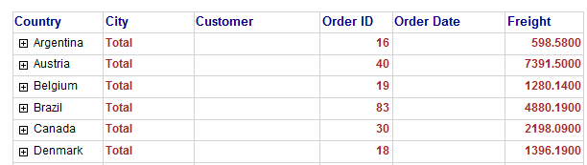
- Switch to design tab, right click data set select Query and change the existing query to:- (note the WHERE clause)

SELECT Customers.CustomerID, Customers.CompanyName, Customers.Country, Customers.City, Orders.OrderID, Orders.OrderDate, Orders.Freight
FROM Customers INNER JOIN
Orders ON Customers.CustomerID = Orders.CustomerID
WHERE (Orders.OrderDate BETWEEN @fromdate AND @todate)
ORDER BY Customers.Country, Customers.City, Customers.CompanyName

- Note in report data window 2 parameters will be created.
- Double click @fromdate parameter
  - Give prompt as Select Start Order Date:-
  - Set data type to datetime
  - Goto Default Values tab, select specify values
  - Click add Type 01/01/1996, click ok
- Similarly configure @todate parameter
  - Prompt: Select End Order Date:-
  - Default value 01/01/1998

- From the toolbox drag a textbox on top of table. Set arial, 14 pt bold size and dark maroon color. Right click the textbox and set following expression :
="Orders Placed by Customers between " +
cstr(Parameters!fromdate.Value) + " and " +
cstr(Parameters!todate.Value)

- Click preview tab, You can expand the country and the city to get the further sales details as shown below:-

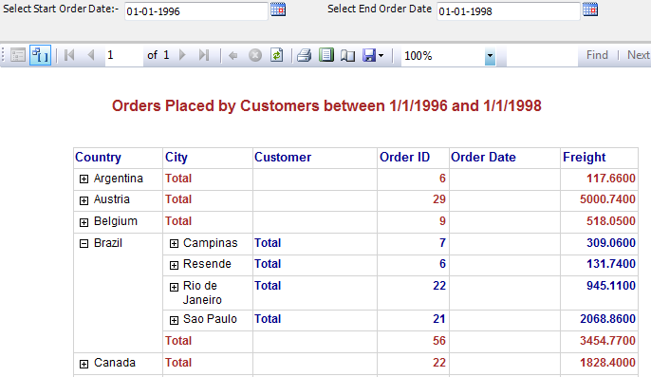

Lab 3 | Using Subreport
Description | We will create 2 reports one which will list product categories and other will display products. The products report will be embedded or added as a subreport in the product categories report.
Objective | To learn  - How to add another report as a subreport  - How to link subreport to parent report via parameters

- Create a report named ProductCategoriesListing which displays the category details in a table as shown below:

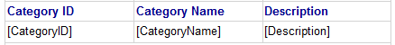

- The DataSet Query is as below:

SELECT CategoryID, CategoryName, Description
FROM Categories
ORDER BY CategoryName

- Preview the report
- Create another report named ProductsListing which will show product details in a table as shown below:-
Note: Set the dimensions of report body so as it matches the dimensions of table report item.

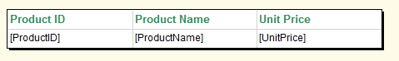

- The Data Set Query of this report:-

SELECT ProductID, ProductName, UnitPrice,
UnitsInStock, CategoryID
FROM Products
WHERE (CategoryID = @catid)
ORDER BY ProductName

- In the report data window goto @catid parameter properties
  - Set data type: integer
  - Select parameter visibilty to hidden
  - Goto Default Values tab, and specify default value as 1
- Preview the report to ensure that it always displays category id 1 products.
- Open ProductCategoriesListing report.
  - Right clck the field row in left grey area, and add a row below.Add such 2 blank rows.

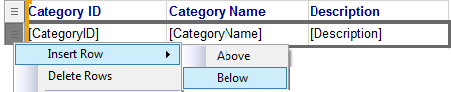
  - Select the cells of 1st blank row and merge the cells.
  - Select the cells of 2nd blank row and merge the cells.
  - In the 2nd row drag Subreport report item from toolbox.
  - Right Click the subreport and in the subreport properties
    - Select ProductsList as subreport.
    - Goto parameters tab, click add and set as shown below:

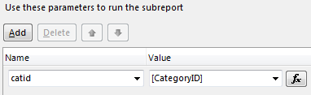

- Right click column header row and add a blank row above
- Right click subreport row and add a blank row below.
- Report design is as below:-
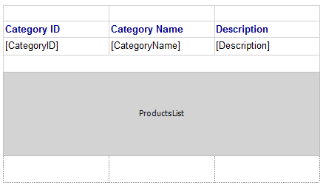

- Preview the report

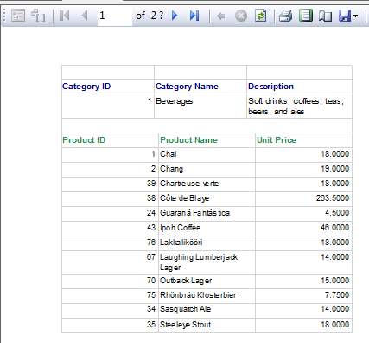

Lab 4 | Creating a Gauge report
Description | We will create a report which will show the total quantity of products on Gauge
Objective | To learn  - How to create Gauge.

- Add a new blank report
  - Right click Reports folder in Soln Explorer, click Add -> New Item.
    - Select report item template
    - Give ProductReportUsingGauge as report name
- Create a local data source based on AdventureWorksDW2008R2 Database and define a data set using following select statement:

SELECT c.EnglishProductCategoryName AS CategroyName, SUM(p.SafetyStockLevel) AS Stock
FROM DimProduct p INNER JOIN DimProductSubcategory s
ON p.ProductSubcategoryKey = s.ProductSubcategoryKey
INNER JOIN DimProductCategory c
ON s.ProductCategoryKey = c.ProductCategoryKey
GROUP BY c.EnglishProductCategoryName

- Drag a table report item.
- Drag CategoryName and Stock fields on to table columns.
- Resize the last column
- Drag Gauge control in the last column from toolbox
- Select Gauge type as linear
- Click the Gauge to display the drop zone, right click LineatPointer1 and select pointer properties
- In LinearPointer Properties dialog box set the Value field to [SUM(Stock)]
- Click Ok
- In Gauge, click the scale to select it, right-click the scale and scale properties
- In minimum value text box type 0 and in maximum value text box type 100000
- Click OK
- Right click on Scale, Select Add Range
- Right click red rectangle above the scale, select range properties
- Set Start Range to 0 and End Range t0 10000
- Click OK
- Save and preview the report
- It will look like as follows
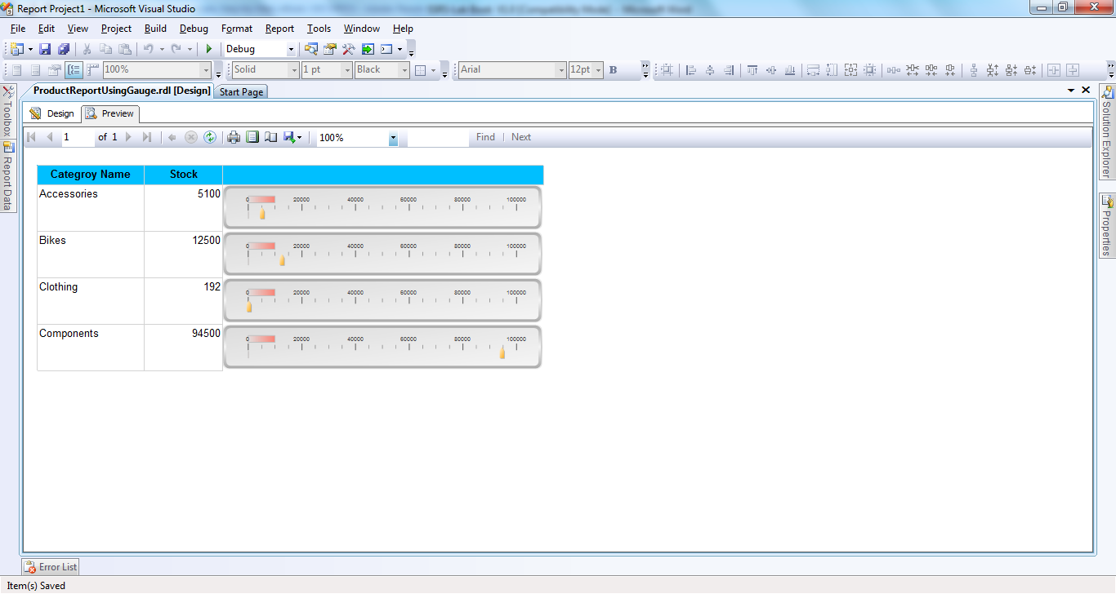

Lab 5 | Creating a Indicator report
Description | We will create a report which will show the indicator that how many products are ordered
Objective | To learn  - How to create indicator.

- Add a new blank report
  - Right click Reports folder in Soln Explorer, click Add -> New Item.
    - Select report item template
    - Give ProductReportUsingIndicator as report name
- Create a local data source based on AdventureWorksDW2008R2 Database and define a data set using following select statement:

SELECT r.OrderDateKey, c.EnglishProductCategoryName AS CategroyName, SUM(r.OrderQuantity) AS OrderQuantity
FROM FactResellerSales r INNER JOIN DimProduct p
ON r.ProductKey = p.ProductKey
INNER JOIN DimProductSubcategory s
ON p.ProductSubcategoryKey = s.ProductSubcategoryKey
INNER JOIN DimProductCategory c
ON s.ProductCategoryKey = c.ProductCategoryKey
GROUP BY r.OrderDateKey, c.EnglishProductCategoryName
ORDER BY r.OrderDateKey, c.EnglishProductCategoryName

- Drag a table report item.
- Drag CategoryName and OrderQuantity fields on to table columns.
- Group the data on the basis of OrderDateKey
- Drag indicator control in the last column from toolbox
- Select indicator type
- Click the indicator to display the drop zone, right click Indicator1 and select indicator properties
- In Indicator Properties dialog box go to Values and States tab
- Select value as SUM(OrderQuantity)
- Click Ok
- Save and preview the report
- It will look like as follows
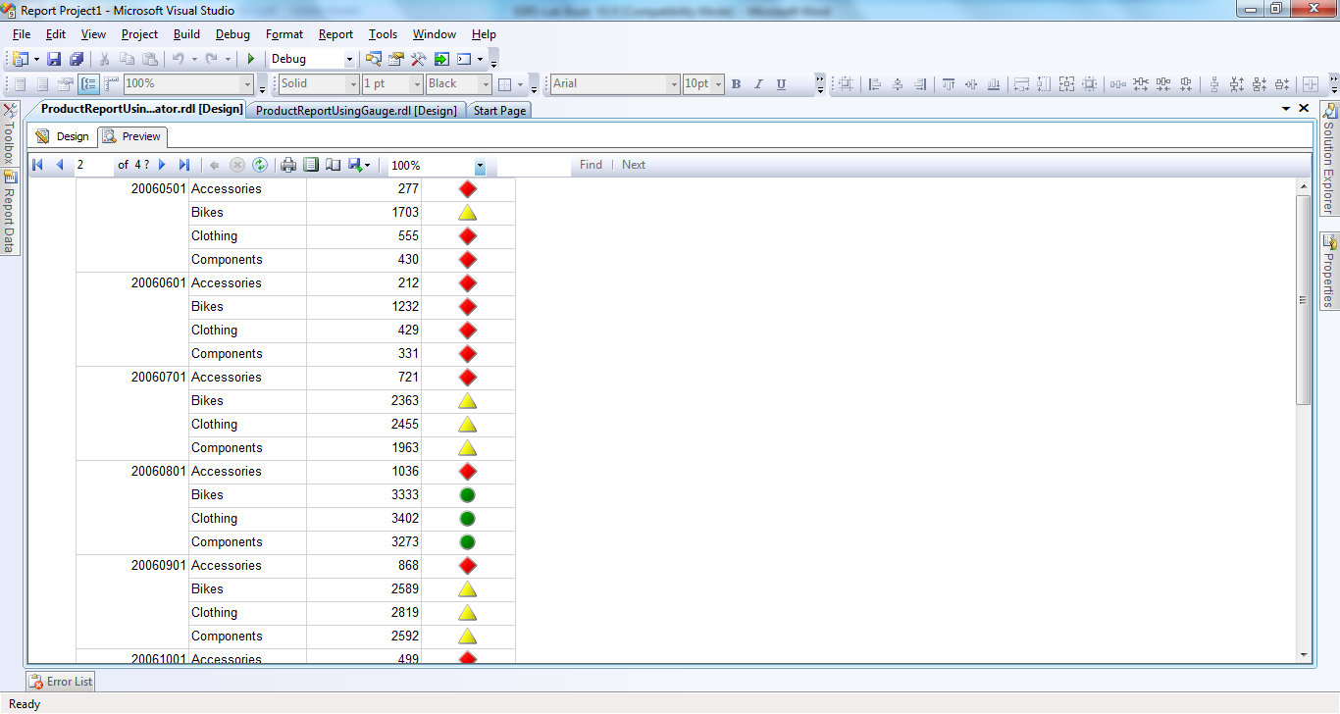

Lab 6 | Creating Databar report
Description | We will create a report which will show the databar for highlighting total product amount
Objective | To learn  - How to create databar.

- Add a new blank report
  - Right click Reports folder in Soln Explorer, click Add -> New Item.
    - Select report item template
    - Give ProductReportUsingDataBar as report name
- Create a local data source based on AdventureWorksDW2008R2 Database and define a data set using following select statement:

SELECT EnglishProductName AS ProductName, (StandardCost * SafetyStockLevel) AS TotalAmount
FROM DimProduct
WHERE StandardCost > 0

- Drag a table report item.
- Drag ProductName and TotalAmount fields on to table columns.
- Resize last column
- Drag databar control in the last column from toolbox
- Select databar type
- Click the databar to display the drop zone, click on plus sign to add value
- Add TotalAmount as Value
- Save and preview the report
- It will look like as follows
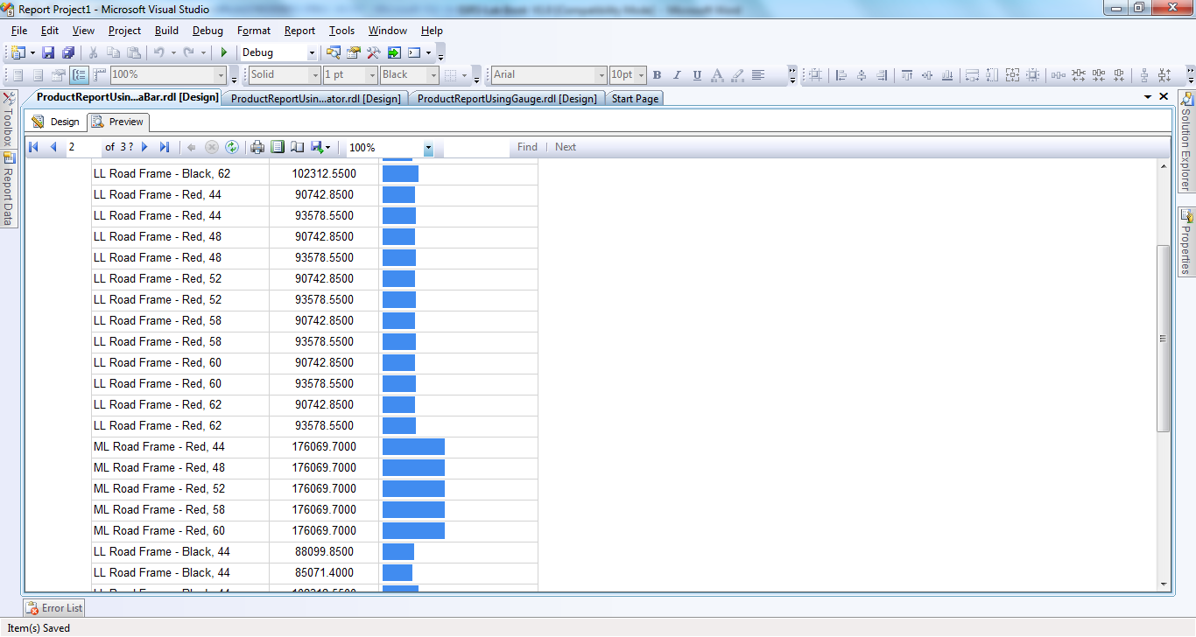

Lab 7 | Creating Sparkline report
Description | We will create a report which will show the sparkline to display the temperature
Objective | To learn  - How to create sparkline.

- Add a new blank report
  - Right click Reports folder in Soln Explorer, click Add -> New Item.
    - Select report item template
    - Give ProductReportUsingSparkline as report name
- Create a local data source based on AdventureWorksDW2008R2 Database and define a data set using following select statement:

SELECT ID, TempMonth, AvgTemp, HighTemp
FROM TempratureTable

- Drag a table report item.
- Drag TempMonth, AvgTemp and HighTemp fields on to table columns.
- Insert a row below second row called Outside Group - Below
- Drag sparkline control in the last row in avgTemp and HighTemp column from toolbox
- Select sparkline type
- Click the sparkline to display the drop zone, click on plus sign to add value
- Add AvgTemp as Value for first and HighTemp value for second
- Save and preview the report
- It will look like as follows
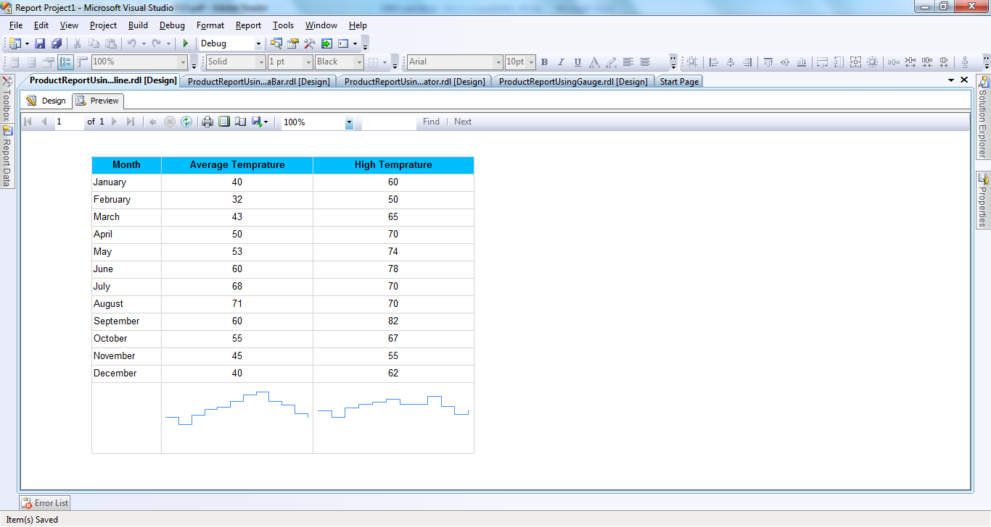

Lab 8 | Creating a Report using Chart
Description | We will create a report which will have a Column Chart which will display Region wise customer distribution
Objective | To learn  - How to use Chart to display the Information

- Add a new blank report
  - Right click Reports folder in Soln Explorer, click Add -> New Item.
    - Select report item template
    - Give RegionWiseCustomerDistribution as report name
- Create a local data source based on shared data source and define a data set using following select statement:

SELECT Region, COUNT(*) AS NOOFCUSTOMERS
FROM Customers
WHERE Region is not null
GROUP BY Region

- Drag a chart and select 3D chart type.

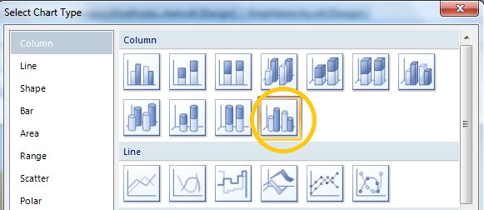

- Drop “NOOFCUSTOMERS” field on Data Field section and Region Field on Series section
- Rt click chart in the middle and select show data labels.
- Change the Chart Title and Axis title as below
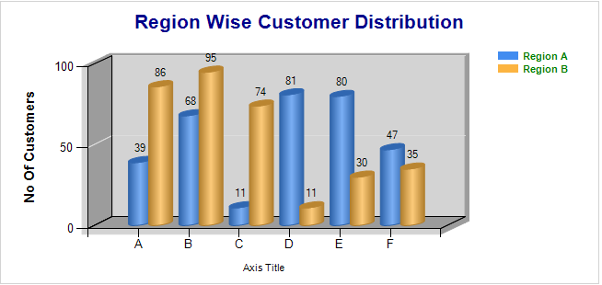
- Run the report.

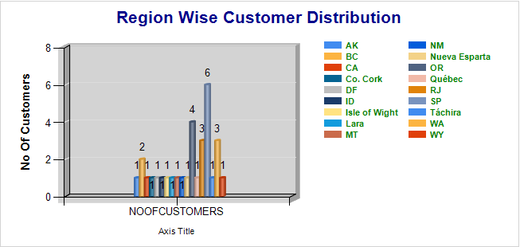

Lab 9 | Creating a Hierarchical Report
Description | We will create a report which will show employees listed according to their reporting hierarchy
Objective | To learn  - How to create a hierarchical report.

- Add a new blank report
  - Right click Reports folder in Soln Explorer, click Add -> New Item.
    - Select report item template
    - Give EmpHeirarchyReport as report name
- Create a local data source based on shared data source and define a data set using following select statement:

SELECT EmployeeID, LastName, FirstName,ReportsTo
FROM Employees

- Drag a table report item. Delete all columns except one
- Right click the only cell in the Details Row and write following expression

=trim(Fields!LastName.Value) + " " +
Fields!FirstName.Value

- Give Employees as column heading and drag texbox and provide report header as below

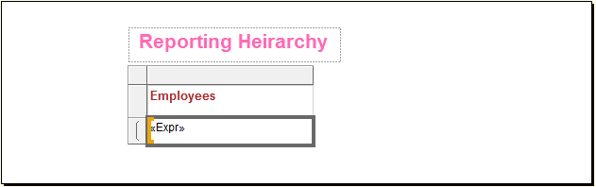

- Rt Click the expression TextBox above, goto Alignment TAB, and write following expr for Left padding option
=CStr(5 + Level()*16) + "pt"

- Double click the details pane in Row Groups.
- Add a group on EmployeeId field

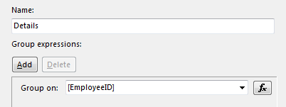
- Goto Advanced TAB, and set recursive parent to ReportsTo field.
- Run the report.

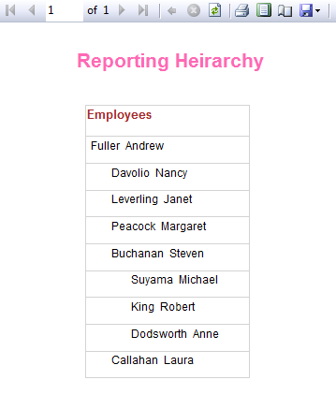

Lab 10 | Creating and Customizing Report Model and using Report Builder
Description | We will create a Report Model based on AdventureWorks Database tables and use it in Report Builder to create a report.
Objective | To learn  - How to Create and Customize Report Model  - How to create report using Report Builder

- In the Microsoft Visual Studio window, click File, point to New, and then click Project.

- Click Report Model Project.In the Name box, type Adventure Works Model. Click OK.
- In Solution Explorer, right-click Data Sources, and then select Add New Data Source connecting AdventureWorks database
- In Solution Explorer, right-click the Data Source Views folder and select Add New Data Source View.
- On the Select Tables and Views page, select all the tables in the Available objects area, and then click the arrow button.
- In Solution Explorer, right-click Report Models and then select Add New Report Model.
- The Report Model Wizard opens.
- On the Welcome to the Report Model Wizard page, click Next.
- On the Select Data Source View page, verify that the AdventureWorks data source view you created in the previous procedure is selected.
- Click Next.
- In the Select model language drop-down list of the Select report model generation rules page, select a language for the model.
- The language you select tells Model Designer which language-specific code it should use when generating user-friendly names for the tables and columns in your database. After you complete the wizard, you can set the Culture property on the model.
- Accept the default rules.
- Click Next.
- On the Collect Model Statistics page, verify that the Update model statistics before generating option is selected, and then click Next.
- On the Completing the Wizard page, verify that AdventureWorks appears in the Name box, and then click Run.
- The report model is created.
- When the wizard is finished, click Finish.
- The AdventureWorks.smdl file appears in Solution Explorer. You have successfully created a report model. In the next procedure, you will explore the model.

To explore the report model
- In the Model pane, select the Customer entity.
- View the center pane. The contents of the Customer entity appear. The attributes include: #Customers, #CustomerID, Account Number, Customer Type, and Modified Date.
- In the List view, select the #Customers attribute, and then view the contents of the Properties window.
- In the List view, select the Customer Type attribute, and then view the contents of the Properties window.
- In the List view, select the Sales Order Headers role, and then view the contents of the Properties window.
- On the File menu, click Save All.
- Next, you will deploy the report model to the report server.

To deploy the report model
- On the Project menu, click AdventureWorks Model Properties.
- After you confirm the deployment properties that you want to use, click OK.
- On the Build menu, click Deploy AdventureWorks Model.
- If the deployment is successful, a Deploy succeeded message is displayed in the Output window. To view the Output window, on the View menu, click Output. If the deployment fails, you need to troubleshoot the reported error.
- In the next procedure, you will test the report model in Report Builder.

To use the model in Report Builder
- Open your browser.
- In the Address bar, type http://localhost/reports.
- The Home page for SQL Server Reporting Services opens.
- On the Report Manager toolbar, click Report Builder.
- In the Getting Started pane, select AdventureWorks and then click OK.
- In the Entities list, select Sales Order Header.
- From the Entities list, drag the Sales Person entity to the design area.
- Notice that the Sales Person National ID Number and Commission Pct fields are added to the design area.
- In the Fields list, double-click Total Total Due.
- Notice that the Total Total Due field is not formatted as a monetary value.
- To see the results of your query, click Run Report.
- On the File menu, click Exit

To add a description to a report model
- Return to the AdventureWorks report model project open in the Business Intelligence Development Studio window.
- In the Tree view, select the Model node.
- In the Properties window, locate the Description property.
- In the Description box, type the following: This report model is for the AdventureWorks database.
- In the Tree view, select the Sales Person entity, and then type the following in the Description box: All sales people are employees.
- In the List view, select the Sales Quota attribute, and then type the following in the Description box: Sales quotas are updated quarterly.
- On the File menu, click Save All.

To add a folder to the report model
- In the Tree view, right-click Model, point to New, and then click Folder.
- The new folder is added at the bottom of the list of entities.
- Right-click the new folder, and select Rename.
- Type Product Details.
- You have successfully added a new folder. Next, to organize the contents of your model, you will add model items to the folder.

To add entities to the folder
- In the Tree view, verify that Model is selected.
- In the List view, select all the entities that begin with the word Product, except for the Product entity itself.
- Drag the selected entities to the Product Details folder in the Tree view.
- You have successfully organized the Product entities within the model.
- To view the contents of Product Details, click the folder.

To rename model items
- In the Tree view, right-click the Sales Order Header entity, and then click Rename.
- Type the following: Sales Order.
- With the Sales Order entity selected, locate the Sales Order Details role in the List view.
- Right-click the Sales Order Details role, and then click Rename.
- Type the following: Sales.
- In the List view, expand the Total Due attribute.
- Right-click Total Total Due, and then click Rename.
- Type the following: Sum Total Due.
- In the Tree view, select the Sales Order Detail entity, and rename the entity Sales.
- In the Tree view, select the Sales Person entity.
- Notice that there is a role called Sales Person within the Sales Person entity. The name of this role is misleading because this role really links to the Employee entity.
- Rename the Sales Person role to Employee.
- On the File menu, click Save All.

To hide a model item
- In the Tree view, select the Sales Order entity.
- In the List view, select the Rowguid attribute.
- In the Properties window, select the Hidden property.
- In the properties drop-down list, select True.
- On the File menu, select Save All.
- In the Tree view, select the Sales Person entity.
- In the Properties window, select DefaultDetailAttributes.
- To edit the property, click the ellipsis (…) button.
- In the Members list of the AttributeReference Collection Editor dialog box, select Commission Pct, and then click Remove.
- Click Add.
- The Default Detail Attributes dialog box appears.
- In the Entities list, select the Employee entity and then select the Contact entity.
- In the Fields list, select First Name, Middle Name, and Last Name, and then click OK.
- Click OK again.
- In the Properties window, note that the DefaultDetailAttributes property indicates that there are four attributes. When the user adds the Sales Person entity to their report, the sales person's National ID Number, and first, middle and last names are added.
- On the File menu, click Save All.

To deploy the report model
- On the Build menu, click Deploy AdventureWorks Model.

To view report model changes in Report Builder
- Launch Report Builder.
- In the Getting Started pane, select the AdventureWorks model, and then click OK.
- To see the Product Details folder, scroll down the list of entities.
- This folder was created in Lesson 3.
- To see the contents of the Product Details folder, click Product Details.
- The entities in this folder were added to the folder in Lesson 3.
- In the Entities list, find the Sales Orders and Sales entities.
- These entities were renamed in Lesson 4.
- Select the Sales Orders entity, and then drag the Sum Total Due field to the design area.
- This field was renamed in Lesson 4 and formatted in Lesson 7.
- Drag the Sales Person entity to left of the Sum Total Due field.
- Notice that the National ID Number, First Name, Middle Name, and Last Name fields are added to the report. These are the default detail attributes that you added to the entity in this lesson. This is the same report that you created earlier except that now your new model changes are displayed.
- To view the results of your report, click Run Report.
- To return to the design area, click Design Report.

Lab 11 | Creating DataBar Report using Report Builder 3.0
Description | We will use Report Builder 3.0 to create a Databar report.
Objective | To learn  - How to create Databar report using Report Builder 3.0

- To use Report Builder 3.0, open your browser.
- In the Address bar, type http://ndainforma/Reports.
- The Home page for SQL Server Reporting Services opens.
- On the Report Manager toolbar, click Report Builder.
- In the Getting Started pane, select New Report and Blank Report then click OK.
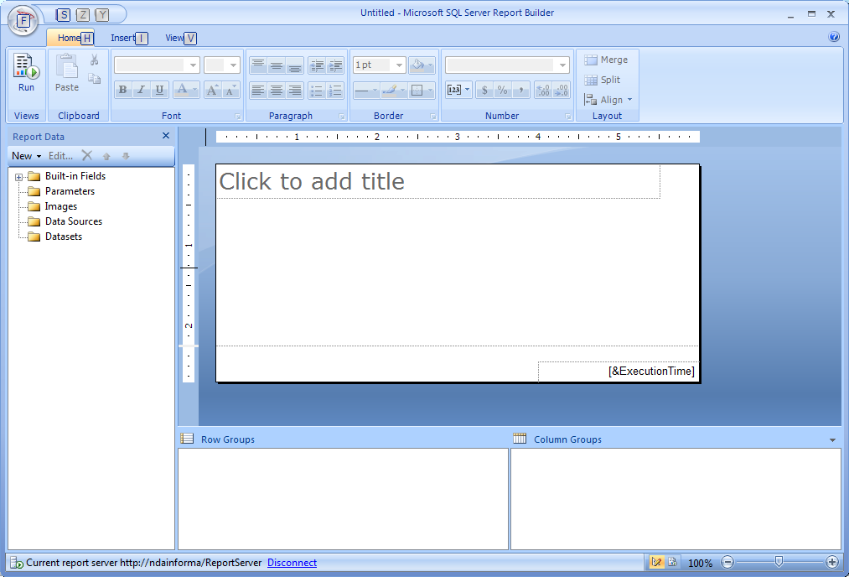
- Right Click on Data Source and select Add Data Source
- It will provide you Data Source Properties Window
- Give Data Source Name
- Choose Use a Connection Embedded in My Report
- Create a Data Source with AdventureWorksDW2008R2 Database
- Click on OK
- Now right click on Data Set and select Add new Data Set
- Give name to DataSet
- Select Use a dataset embedded in my report
- Select Data Source
- Type following query
SELECT EnglishProductName AS ProductName, (StandardCost * SafetyStockLevel) AS TotalAmount
FROM DimProduct
WHERE StandardCost > 0
- Click OK
- Now in Menu Go to Insert and Select Insert Table
- And add table on your designer window
- Drag Product Name and Total Amount on Table
- Right Click in 3rd Column of 2nd Row and click on Insert and Select Databar
- Select Databar Type
- Click the databar to display the drop zone, click on plus sign to add value
- Add TotalAmount as Value
- Save the report. It will save the report on the server
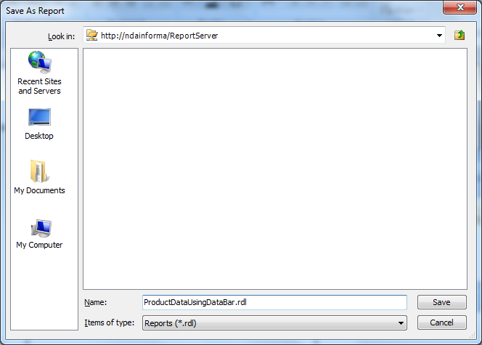
- Click on Run to run the report
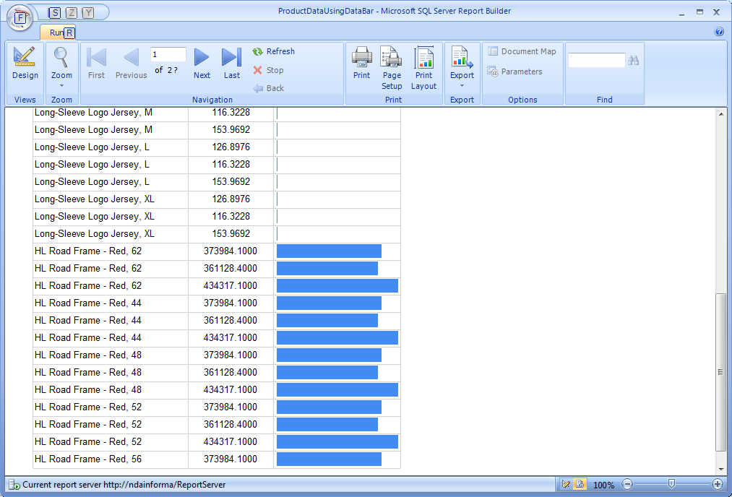

Lab 12 | Creating Sparkline Report using Report Builder 3.0
Description | We will use Report Builder 3.0 to create a Sparkline report.
Objective | To learn  - How to create Sparkline report using Report Builder 3.0

- To use Report Builder 3.0, open your browser.
- In the Address bar, type http://ndainforma/Reports.
- The Home page for SQL Server Reporting Services opens.
- On the Report Manager toolbar, click Report Builder.
- In the Getting Started pane, select New Report and Blank Report then click OK.
- Right Click on Data Source and select Add Data Source
- It will provide you Data Source Properties Window
- Give Data Source Name
- Choose Use a Connection Embedded in My Report
- Create a Data Source with AdventureWorksDW2008R2 Database
- Click on OK
- Now right click on Data Set and select Add new Data Set
- Give name to DataSet
- Select Use a dataset embedded in my report
- Select Data Source
- Type following query
SELECT ID, TempMonth, AvgTemp, HighTemp
FROM TempratureTable
- Click OK
- Now in Menu Go to Insert and Select Insert Table
- And add table on your designer window
- Drag TempMonth, AvgTemp and HighTemp fields on to table columns.
- Insert a row below second row called Outside Group – Below
- Right click in last row, click on insert and select Sparkline in avgTemp and HighTemp column from toolbox
- Select Sparkline Type
- Click the Sparkline to display the drop zone, click on plus sign to add value
- Add AvgTemp as Value for first and HighTemp value for second
- Save the report. It will save the report on the server
- Click on Run to run the report

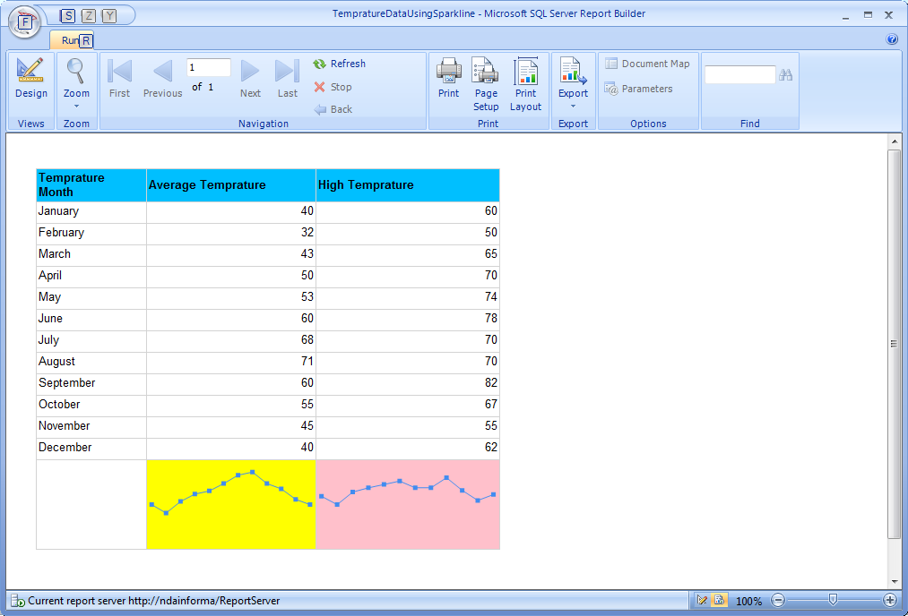

Lab 13 | Creating Chart Report using Report Builder 3.0
Description | We will use Report Builder 3.0 to create a chart report.
Objective | To learn  - How to create chart report using Report Builder 3.0

- To use Report Builder 3.0, open your browser.
- In the Address bar, type http://ndainforma/Reports.
- The Home page for SQL Server Reporting Services opens.
- On the Report Manager toolbar, click Report Builder.
- In the Getting Started pane, select New Report and Blank Report then click OK.
- Right Click on Data Source and select Add Data Source
- It will provide you Data Source Properties Window
- Give Data Source Name
- Choose Use a Connection Embedded in My Report
- Create a Data Source with AdventureWorksDW2008R2 Database
- Click on OK
- Now right click on Data Set and select Add new Data Set
- Give name to DataSet
- Select Use a dataset embedded in my report
- Select Data Source
- Type following query
SELECT c.EnglishProductCategoryName AS CategoryName, SUM(r.SalesAmount) AS SalesAmount
FROM FactResellerSales r INNER JOIN DimProduct p
ON r.ProductKey = p.ProductKey
INNER JOIN DimProductSubcategory s
ON s.ProductSubcategoryKey = p.ProductSubcategoryKey
INNER JOIN DimProductCategory c
ON c.ProductCategoryKey = s.ProductCategoryKey
GROUP BY c.EnglishProductCategoryName
ORDER BY c.EnglishProductCategoryName
- Click OK
- Now in Menu Go to Insert and Select Chart >> Insert Chart
- Select chart type as Scatter Chart
- Click the chart to display the drop zone, click on plus sign to add value
- Add SalesAmount As a value
- Add Category Group as CategoryName
- Select the series point, right click and select series properties
- In Series Properties Window, Select Marker, Change Marker Size to 12 pt
- Right click on series and select show data labels
- Save the report. It will save the report on the server
- Click on Run to run the report
